The Pacific Trails Resort, Located right on the California North Coast. The resort offers a quiet getaway with luxury camping in yurts along with an upscale lodge for dining and visiting with fellow guests. The resort has website which includes a home page, a page about the special yurt accommodations, a reservations page with a contact form, and a page to describe the activities available at the resort.
A site map for the Pacific Trails Resort website is shown in Figure 1. The site map describes the architecture of the website—a Home page with three main content pages: Yurts, Activities, and Reservation.
Home Page
Activities
Reservations
Yurts
Yurts

Figure 1: The Pacific Trail Resort site map
Figure 2 displays wireframe for two column page layout for the Pacific Trail Resort website. The wireframe contains a wrapper, header area, a navigation area, a main content area, and a footer for copyright information.
header
nav
main
footer
wrapper

Figure 2: The Pacific Trail Resort WireFrame
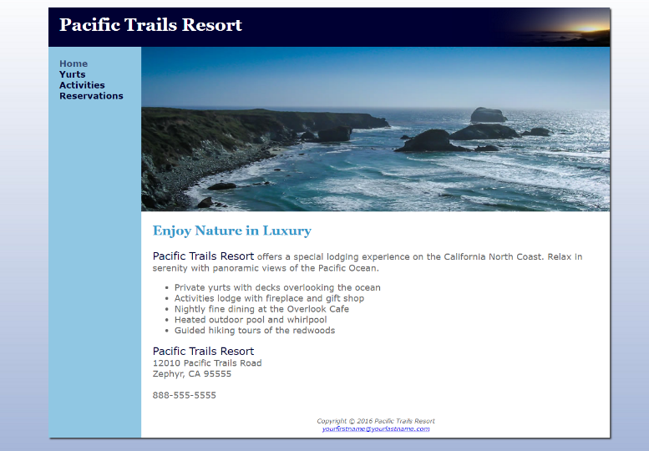
Figure 3 shows the desktop display of the Pacific Trail website’s home page (index.html).

Figure 3: Two column desktop display

Figure 4 shows the tablet display of the Pacific Trail website’s home page (index.html).
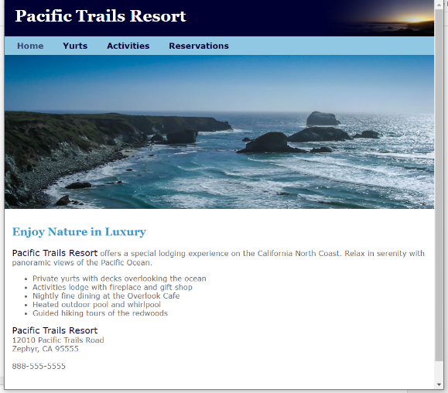

Figure 4: Tablet display

Figure 5 shows the smartphone display of the Pacific Trail website’s home page (index.html).
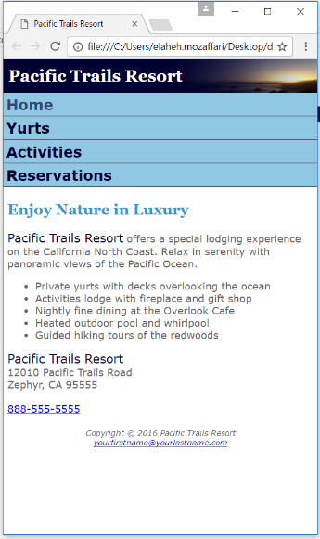

Figure 5: Smartphone display

Task:
You are provided with a complete HTML file and a basic CSS structure (selectors without any styles). Your job is to create a fully responsive website that works on desktop, tablet, and mobile screens, with the output in the browser similar to the screenshots provided in Figures 3, 4, and 5. You can do this by completing the CSS file pacific.css. You can either fill out the attributes inside the provided CSS selectors or delete the structure selectors and write your own CSS from scratch.
Provided Resources:
- Completed index.html, Incomplete pacific.css, coast.jpg and sunset.jpg
Your Tasks:
- Create a folder and name it Test1_YourLastName_YourFirstName_StudentID. Copy all the provided files (index.html, pacific.css, coast.jpg, sunset.jpg) into this folder.
  - Example folder name: Test1_Doe_John_123456789.
- Write CSS for Desktop, Tablet, and Mobile:
  - The HTML is complete, and your task is to write the CSS to style the website and make it responsive for all devices.
  - You can either fill out the attributes inside the provided CSS selectors in pacific.css or delete the structure selectors and create your own CSS from scratch.
- Desktop View:
  - Refer to Figure 3 as the guide for designing the desktop layout.
- Tablet View:
  - Add a media query for typical tablet screens.
  - Refer to Figure 4 for the required layout adjustments for tablet screens.
- Mobile View:
  - Add a media query for mobile screens.
  - Refer to Figure 5 for the desired layout adjustments for mobile screens.
- Submission Instructions:
  - Zip the entire folder after completing the CSS.
  - Upload the zipped folder to Omnivox with your name and student ID in the filename.

